Introduction
The aim of this exercise is to display, search, add and modify employee’s info that presents inside a company.

The Exercise is divided into three frames:

Frame 1:
In this frame, the user has the possibility to search by Employee Name for the data present in the grid of the Frame2, so we should have two combo boxes, one text input and a search button:
- The first combo displays Search by criteria (Employee Name columns).
- The second Combo manages to display criteria’s condition:
  - It is containing:’ start with’ and ‘contains’ keywords.
When Clicking on “Search” button, the rows of the table in the Frame 2 with the corresponding data should be highlighted.

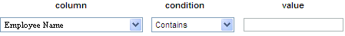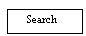

Frame 2:
In this frame, we should display employee’s info inside HTML table selected from database:
- Employee Id
- Employee Name
- Employee Address
- Employee phone Number
- Employee Age
Employee Id | Employee Name | Employee Address | Employee Phone number | Employee Age
1 | Charbel | Beirut | 70/111211 | 29
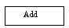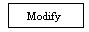
Also, we have an “ADD” button that used to add a new employee to the company
When clicking on this button we enable the form of the Frame 3.

Frame 3:
In this frame, we have a form that is used to enter employee info (Already used in the grid of the previous frame), all the fields are required (mandatory), and a “Save” button that submits the information keyed inside database once done, the Frame 2 should be reloaded in order to be updated by the new added records.

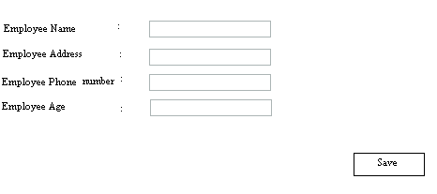

The user can modify employee’s info by selecting an Employee Id in the grid and clicking on the button “Modify”. When clicking, the Frame 3 should be filled and the user can modify the existing info. By Clicking on the “Save” button Employee’s data should be updated based on the change made and the Frame 2 should be reloaded in order to be updated by the change done.

Hint:
you may use
- document.location.href
- ArrayList
- Session

